**Detailed Software Technical Design (DSTD)**

**For**

***V2V COURIERS***

***(Courier Service Provider)***

Table of Contents

1 Introduction.. 5

1.1 Purpose. 5

1.2 Scope. 5

1.3 Definitions, Acronyms and Abbreviations. 5

1.4 References. 5

2 Assumptions.. 6

3 PROJECT OVERVIEW AND USECASE DIAGRAMS.. 6

4 Detailed Design for Module: <<Module Name>>. 7

4.1 Detailed Design for Feature: <<Feature Name>>. 7

**4.1.1** **User Profile**. 7

**4.1.2** **Navigation Map**.. 7

**4.1.3** **UI Screen Design**.. 7

*4.1.3.1* *Screen Layout* 7

*4.1.3.2* *Validations*. 8

**4.1.4** **Object Model/Data Flow Design**.. 8

*4.1.4.1* *Interface Description*. 8

*4.1.4.2* *Class Design*. 8

4.1.4.2.1 Algorithmic/Business Logic Description (Optional) 8

4.1.4.2.2 Local Data Structure (Optional) 8

*4.1.4.3* *Data Transfer/Value objects*. 8

*4.1.4.4* *Related Database Tables*. 9

*4.1.4.5* *Dependencies with Other Sub-systems/Components*. 9

4.2 Detailed Design for Feature: <<Feature Name>>. 9

5 Detailed Design for Module: <<Module Name>>. 10

6 Database Design.. 11

6.1 Entity Relationship Diagrams. 11

7 Packaging/Folder Structure and System Artifacts.. 12

7.1 System Artifacts. 12

8 Core Technical Services Design.. 13

8.1 Persistence. 13

8.2 Inter-process Communication. 13

8.3 Authentication and Authorization. 13

8.4 Error Handling.. 13

8.5 Logging.. 13

8.6 Transaction Management. 13

8.7 Other Applicable Technical Services. 13

9 Non Functional Requirements.. 14

Appendix.. 14

1. Design Metrics to be Used.. 14

2. Supplementary Information. 14

3. DQI – Design Quality Index Checklist. 14

**Document Revisions**

|  |  |  |  |  |  |
| --- | --- | --- | --- | --- | --- |
| **Date** | **Version** | **Description** | **Author** | **Reviewer** | **Approver** |
|  |  |  |  |  |  |
|  |  |  |  |  |  |

**Information Handling**

These documents are strictly for **Virtusa/Client** use only. They shall not be shared with an external party other than the client concerned. These documents should always be kept securely and employees shall use reasonable care protecting these documents from unauthorized use or disclosure to a third party. This category also covers client intellectual property where Virtusa has a non-disclosure agreement with the client.

# **1** **Introduction**

## **1.1** **Purpose**

The Purpose of the V2V Couriers is to automate the existing manual operations with the help of a computer. In order to achieve high operational efficiencies , high customer experience and reducing operational cost.

The main objective of this project is to manage the details of courier,customer,delivery,payment.

This project manages all the information about courier,tracking of courier,payment and delivery.

## **1.2** **Scope**

V2V Couriers is an integrated full business software framework for an enterprise which possesses procedures in domestic and international courier services.V2V couriers handles the end to end process starting from initiating a courier order, driver pickup and delivery of a courier business.

The scope of this project is that the courier is to predict the time required to reach the destination.

The main aim of this project is to computerize the maintenance of courier delivery with minimal human work and less in operational cost.

## **1.3** **Definitions, Acronyms and Abbreviations**

[This sub-section must provide definitions for all the terms, acronyms, and abbreviations used in this document.]

## **1.4** **References**

[This sub-section must provide a complete list of all references. Identify each document by title, document number and the version. Specify the sources from which the references can be obtained.

# **2** **Assumptions**

[List the assumptions, if any, here.]

# **3** **PROJECT OVERVIEW AND USECASE DIAGRAMS**

**PROJECT OVERVIEW:**

V2V Couriers handles the end to end process starting from initiating a courier order, driver pickup and delivery of a courier business.

It covers all the controls and processes involved in Courier Services,Domestic Pickup and Delivery.

**USE CASE DIAGRAM:**

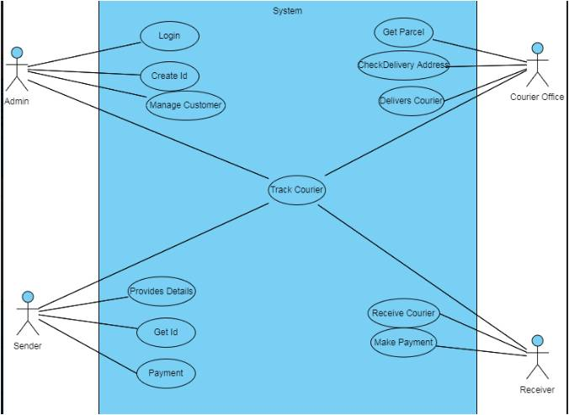

# **4** **Detailed Design for Module: <<Module Name>>**

This section describes the detailed design for the <<Module Name>> module/sub-system. *[Save the design images separately as rose, Visio or jpeg images and provide reference or link to them from the word document.]*

*To include Sequence diagrams for each of the transactions and data flow*

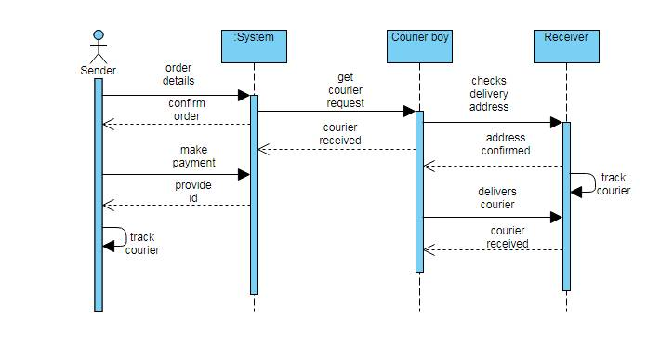

## **4.1** **Detailed Design for Feature: <<Feature Name>>**

[This section describes the detailed design for the feature including the user interface design.]

### **4.1.1** **User Profile**

[Describe the different user types with the security profiles and specify the roles that can access these screens.]

### **4.1.2** **Navigation Map**

[Describe the navigation map along with use case traceability of all screens for this feature.]

### **4.1.3** **UI Screen Design**

|  |  |
| --- | --- |
| **Page Summary** | |
| **Name** | Search for Customer File |
| **Description** | The user retrieves the customer information based on the search criteria such as File ID, last name, first name, middle name, business name, SSN/TIN, address, city, state and/or zip. |
| **Use Case Number** | UC-002 |

#### *4.1.3.1* *Screen Layout*

[Include a screen shot and describe each element/button in the following table.]

#### *4.1.3.2* *Validations*

|  |  |  |
| --- | --- | --- |
| **Error Trigger** | **Action** | **Description** |
| If the user group is not selected. | Displays the message “Please select a User Group from the list”. | Prompts the user to select an entry from the User Group list. |
| User enters an invalid date | Displays the message “Enter a valid date. The date must be in <mm-dd-yyyy> format”. | Displays invalid date message. |

### **4.1.4** **Object Model/Data Flow Design**

[This sub-section describes the detailed design for the system pertaining to the <<Feature Name>> feature. Interaction diagrams showing the details of the component structure, behavior, or information/control flow may be included in the sub-section devoted to that particular component.]

#### *4.1.4.1* *Interface Description*

[Describe the interfaces including component interfaces and interfaces to other systems, products, or networks.]

#### *4.1.4.2* *Class Design*

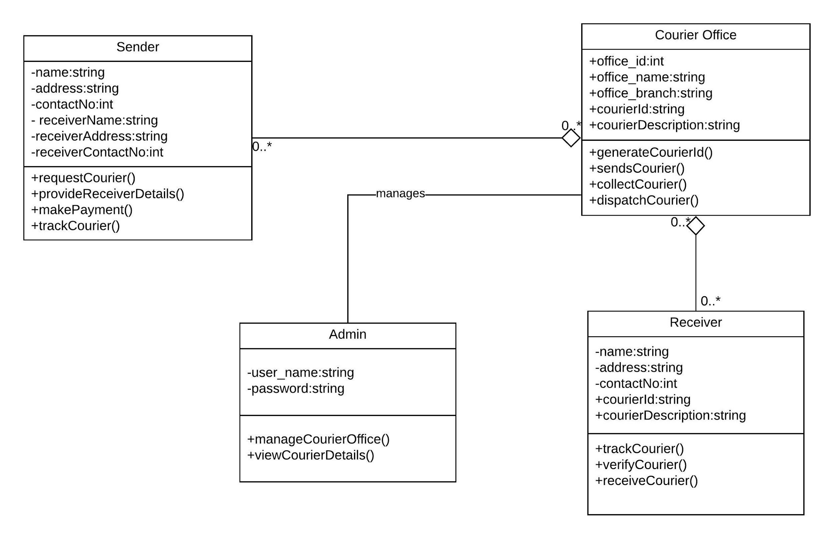

[This sub-section is repeated for each of the key design classes. Describe the detailed class design here.]

##### **4.1.4.2.1** **Algorithmic/Business Logic Description (Optional)**

[Describe complex algorithms used in the class (if any).]

##### **4.1.4.2.2** **Local Data Structure (Optional)**

[Describe key data structure algorithms used (if any).]

#### *4.1.4.3* *Data Transfer/Value objects*

[Based on the design pattern being used, identify and describe the value/transfer objects.]

#### *4.1.4.4* *Related Database Tables*

[Give the list of related database tables.]

#### *4.1.4.5* *Dependencies with Other Sub-systems/Components*

[Describe the dependencies with other sub-system/components, if any.]

## **4.2** **Detailed Design for Feature: <<Feature Name>>**

Repeat all sub-sections given in 3.1 for this feature.

# **5** **Detailed Design for Module: <<Module Name>>**

[Detailed design for Module 2.]

Repeat all sub-sections given in section 3 for this module.

**6** **Database Design**

[This section describes the persistent data and metadata used and generated by the module/sub-system. This will include database schemas (if the database schema is large, use a separate document for database design), registry structures, property file structures, etc.

|  |  |
| --- | --- |
| **Models** | **Tools** |
| Database Entity Relationship Diagrams | ERWin |
| Object Models | Rational Rose |

## **6.1** **Entity Relationship Diagrams**

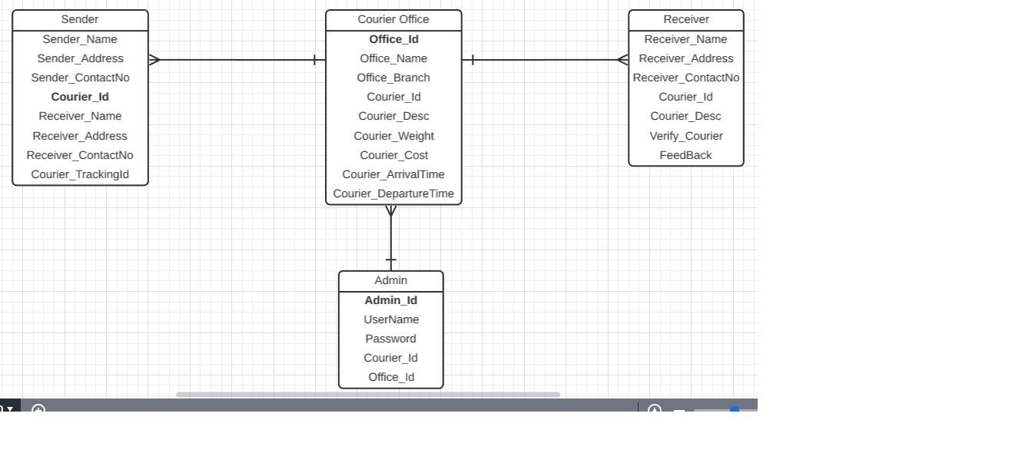

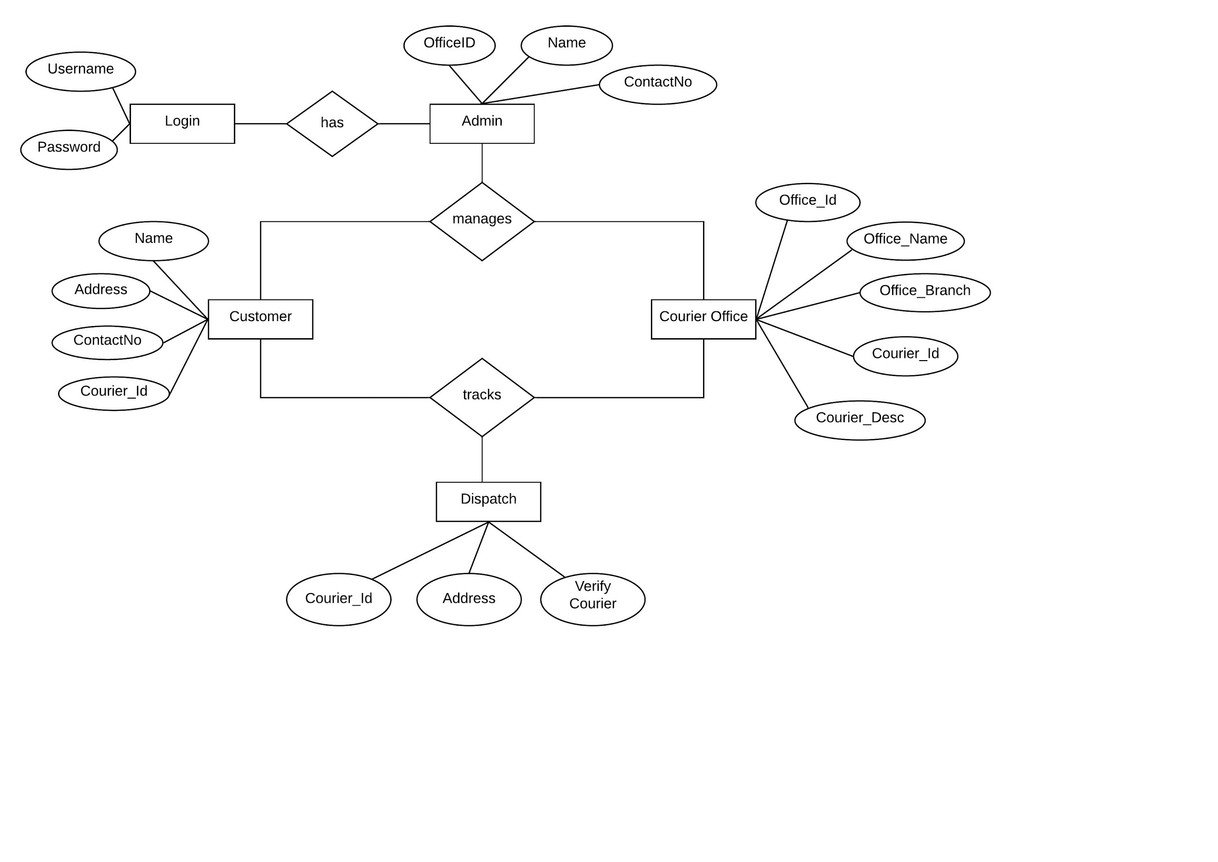**7** **Packaging/Folder Structure and System Artifacts**

[This section describes the file structure for the <Project Name> project, which will indicate where the code, unit tests, executables, libraries, etc. are to be placed during implementation. Optionally the file structure can be described in a separate GA chapter and a reference given here.]

**[Sample structure**

**End Sample Structure]**

## **7.1** **System Artifacts**

[Provide information on the Registry structure, INI files, property files, configuration files, etc.]

# **8** **Core Technical Services Design**

[This section describes the detailed design and usage pattern for the core technical services of the system.]

## **8.1** **Persistence**

[This sub-section captures the detailed design and usage patterns of the persistence service for the application.]

## **8.2** **Inter-process Communication**

[This sub-section captures the detailed design and usage patterns of the inter-process communication framework for the application.]

## **8.3** **Authentication and Authorization**

[This sub-section captures the detailed design and usage patterns of the security services for the application.]

## **8.4** **Error Handling**

This sub-section captures the detailed design and usage patterns of the error handling services for the application.]

## **8.5** **Logging**

[This sub-section captures the detailed design and usage patterns of the logging framework for the application.]

## **8.6** **Transaction Management**

[This sub-section captures the detailed design and usage patterns of the Transaction Management service for the application.]

## **8.7** **Other Applicable Technical Services**

[This sub-section captures the detailed design and usage patterns of the other core technical services to be handled by the system such as the installation mechanism, failure prevention, fault tolerance, caching design, internationalization, validation framework, client and server initialization, error handling, etc.]

# **9 Non Functional Requirements**

# **Appendix**

[Presents information that supplements the design specification.]

## **1.** **Design Metrics to be Used**

[A description of all design metrics to be used during the design activity is listed here.]

## **2.** **Supplementary Information**

[Provide as required.]

## **3.** **DQI – Design Quality Index Checklist**

This checklist shall be used to perform self-review as a reference while preparing software design.